

JAVA PROJECT REPORT ON
ONLINE ORDER PROCESSING AND INVOICE GENERATION SYSTEM

Submitted by
MITRAA J
25BCS129

Under the Guidance of
Mr Aravind
Technical Trainer
Technical Department, KG College of Arts and Science

Academic Year: 2025 – 2026
APRIL 2026
Semester: II

DECLARATION
I hereby declare that the project entitled “ONLINE ORDER PROCESSING AND INVOICE GENERATION SYSTEM” submitted in partial fulfillment of the requirements for the course BSC Computer science is a record of my original work carried out under the guidance of Mr Aravind Technical Trainer, Technical Department, KG College of Arts and Science.
I further declare that this project has not been submitted previously, either in part or in full, for the award of any degree, diploma, or other similar title, at this or any other institution.
I have acknowledged all sources of information used in this project wherever applicable.

April 2026
Coimbatore

_____MITRAA J_____

CERTIFICATE
This is to certify that the project entitled “ONLINE ORDER PROCESSING AND INVOICE GENERATION SYSTEM” is a bona fide work carried out by Mitraa j,1st year-B, BSC Computer science, KG College of Arts & Science, in partial fulfillment of the requirements for the course Java programming.
This project has been completed under my supervision and guidance during the academic period April 2026.

Place: Coimbatore
Date:10/04/2026

Submitted for the Viva-Voce Examination held on ______10/04/2026__________________

Guide: Head of the Department
(Technical Trainer, KGCAS) (Technical Head, KGCAS)

___Mr Aravind __________ __Mr BooplanSundaramoorthy__

TABLE OF CONTENTS
S. No. | Topics | Page. No.
1 | Introduction
1.1 | Objective
1.2 | Overview
1.3 | Features
2 | Program Analysis
2.1 | Problem Definition
2.2 | Project Overview
2.3 | Scopes and Limitations
3 | System Design
3.1 | Modules
4 | Methodology
4.1 | Problem Analysis
4.2 | System Design
4.3 | Program Development
4.4 | Testing and Validation
4.5 | Result and Documentation
4.6 | Algorithm
4.7 | Flowchart
5 | Source Code
6 | Input and Output Screens
7 | Discussion and Conclusion
7.1 | Discussion
7.2 | Conclusion
8 | References

ABSTRACT
The Online Order Processing and Invoice Generation System is a software application designed to automate and simplify the process of managing customer orders and generating invoices efficiently. In traditional business environments, order processing and billing are often performed manually, which can lead to errors, delays, and difficulty in maintaining records. This system aims to overcome these challenges by providing a computerized solution that ensures accuracy, speed, and reliability.The system allows users to manage customer details, product information, and order records through a user-friendly interface. When an order is placed, the system automatically calculates the total amount based on product price and quantity, and generates an invoice instantly. All transaction details are stored in a centralized database, which enables easy retrieval and management of data.The application is developed using Java for the front-end logic and MySQL for database management. It follows a modular design approach, ensuring flexibility and scalability. The system also includes features such as data validation, secure login, and report generation, which enhance its usability and performance.This system is highly beneficial for small and medium-scale businesses, as it reduces manual workload, minimizes errors, and improves overall efficiency. It also enhances customer satisfaction by providing quick and accurate billing services.In conclusion, the Online Order Processing and Invoice Generation System provides an effective and reliable solution for modern business needs, ensuring smooth operation and better data management.

- INTRODUCTION
The Online Order Processing and Invoice Generation System is a software application designed to simplify and automate the process of handling customer orders and generating invoices in a digital format. In today’s fast-growing digital world, businesses are moving from manual systems to automated systems to improve efficiency, reduce errors, and save time. This system plays a crucial role in managing orders, tracking transactions, and generating accurate invoices instantly.
Traditionally, order processing and invoice generation were done manually using paper-based systems or basic spreadsheets. This approach was time-consuming, prone to human errors, and difficult to manage as the business grew. With the introduction of this system, businesses can now process orders in real-time, maintain customer records, calculate totals automatically, and generate invoices without manual effort.
This system is especially useful for small and medium-scale businesses such as retail shops, restaurants, online stores, and service providers. It ensures that all transactions are recorded systematically and can be accessed anytime for future reference. The automation also improves customer satisfaction by providing quick and accurate billing.
The system is developed using programming technologies such as Java and database systems like MySQL. It provides a user-friendly interface where users can add products, process orders, and generate invoices easily. Overall, this system enhances productivity, reduces operational costs, and ensures better business management.

1.1 Objective
The main objective of the Online Order Processing and Invoice Generation System is to automate the entire process of order handling and billing. The system aims to eliminate manual errors and improve efficiency in business operations.
The key objectives include:
- To provide a digital platform for managing customer orders.
- To generate invoices automatically with accurate calculations.
- To maintain records of all transactions for future reference.
- To reduce paperwork and manual workload.
- To improve speed and accuracy in billing.
- To enhance customer satisfaction through quick service.
- To provide easy access to order history and reports.
By achieving these objectives, the system helps businesses operate smoothly and efficiently.

1.2 Overview
The system consists of different modules that work together to process orders and generate invoices. The user can log into the system and perform various operations such as adding products, placing orders, and generating invoices.
When a customer places an order, the system records the order details, calculates the total amount, applies taxes if necessary, and generates an invoice. The invoice can be printed or saved digitally.
The system also maintains a database where all information is stored securely. This includes customer details, product information, order history, and invoice records. The data can be retrieved whenever needed.
Overall, the system provides a complete solution for managing orders and billing in an organized and efficient manner.

1.3 Features
The Online Order Processing and Invoice Generation System includes several important features:
- User-Friendly Interface: Easy to use for both beginners and experienced users.
- Order Management: Allows users to add, update, and delete orders.
- Product Management: Stores product details like name, price, and quantity.
- Automatic Invoice Generation: Generates invoices instantly after order processing.
- Accurate Calculations: Automatically calculates total amount and taxes.
- Data Storage: Saves all records in a database.
- Search Functionality: Easily search for orders and invoices.
- Report Generation: Generates reports for analysis.
- Secure System: Protects data from unauthorized access.

2 . PROGRAM ANALYSIS
Program Analysis is an important phase in software development where the existing system is studied, problems are identified, and requirements for the new system are clearly defined. It helps in understanding what the system should do and how it can be developed efficiently.
In the case of the Online Order Processing and Invoice Generation System, program analysis focuses on identifying the drawbacks of the manual system and proposing an automated solution that improves efficiency, accuracy, and data management.

2.1 Problem Definition
In many small and medium-scale businesses, order processing and invoice generation are still performed manually. This leads to several issues that affect the overall efficiency of the business.
One of the major problems is time consumption. Manual processes require significant time to record orders, calculate totals, and prepare invoices. This delays customer service and reduces productivity.
Another issue is human error. Manual calculations often lead to mistakes in billing, which can result in financial losses and customer dissatisfaction. Errors in data entry can also cause incorrect records.
Data management is also a major challenge. Maintaining physical records is difficult, and there is a risk of losing important information. Retrieving past records is time-consuming and inefficient.
The lack of automation also affects scalability. As the business grows, managing a large number of transactions becomes increasingly difficult.
Therefore, there is a need for a system that can automate these processes and provide an efficient solution.

2.2 Project Overview
The Online Order Processing and Invoice Generation System is designed to address the problems identified in the existing system. It provides an automated platform for managing orders and generating invoices.
The system allows users to enter customer details, select products, and process orders easily. It automatically calculates the total amount and generates invoices instantly. This reduces manual effort and improves accuracy.
The system also maintains a database of all transactions. This allows users to access past records and generate reports for analysis. The system ensures data security and integrity.
The project is developed using Java for the application logic and MySQL for the database. It provides a graphical user interface for easy interaction.

2.3 Scopes and Limitations

Scope
The system has a wide scope and can be used in various types of businesses. It can handle multiple users and transactions efficiently. The system can also be extended with additional features such as online payment integration and cloud storage.
The system supports real-time processing, allowing users to manage orders instantly. It also provides reporting features that help in decision-making.

Limitations
Despite its advantages, the system has some limitations. It requires basic computer knowledge to operate. The system may also require regular maintenance and updates.
If the system is not connected to a cloud server, data access may be limited to a single location. Initial setup costs may also be a concern for small businesses.

- SYSTEM DESIGN
System Design is one of the most important phases in software development. It defines how the system will function, how different components will interact, and how data will be processed and stored. A well-designed system ensures efficiency, scalability, and reliability.
The Online Order Processing and Invoice Generation System is designed using a modular and structured approach. Each module performs a specific task and interacts with other modules to complete the overall process. The system follows a layered architecture, which includes the user interface layer, application layer, and database layer.
The design focuses on simplicity, usability, and performance. It ensures that users can easily interact with the system while the backend handles all processing efficiently.

3.1 Modules
The system is divided into several modules, each responsible for a specific function.
1. User Module :
The User Module handles authentication and user management.
Functions:
- Login and logout
- User authentication
- Access control
This module ensures that only authorized users can access the system. It improves security and protects sensitive data.
2. Product Module :
The Product Module manages product-related information.
Functions:
- Add new products
- Update product details
- Delete products
- View product list
Each product includes:
- Product ID
- Product Name
- Price
- Quantity
This module ensures that the system always has updated product information

3. Customer Module :
This module stores and manages customer details.
Functions:
- Add customer information
- Update customer details
- View customer records
Customer details include:
- Customer ID
- Name
- Contact details
This helps in maintaining proper customer records and improves service.
4. Order Module:
The Order Module is responsible for processing customer orders.
Functions:
- Create new orders
- Select products
- Enter quantity
- Calculate total
When an order is placed:
- User selects products
- Enters quantity
- System calculates total automatically
This module ensures accurate and efficient order processing
5. Invoice Module :
The Invoice Module generates invoices after order processing.
Functions:
- Generate invoice
- Display invoice
- Print invoice
- Save invoice
Invoice includes:
- Customer details
- Product details
- Total amount
- Date
This module ensures quick and accurate billing.
6. Database Module :
This module handles all database operations.
Functions:
- Store data
- Retrieve data
- Update records
- Delete records
The database acts as the backbone of the system.

4.METHODOLOGY

Methodology refers to the systematic approach used to design, develop, test, and implement the Online Order Processing and Invoice Generation System. It provides clear step-by-step process to ensure that the system is developed efficiently and meets all user requirements.
The methodology used in this project follows a structured approach similar to the Software Development Life Cycle (SDLC). Each phase plays a crucial role in building a reliable and efficient system.

4.1. Problem Analysis
Requirement Analysis is the first and most important step in the methodology. In this phase, the needs of the users and the problems in the existing system are identified.

Activities Performed
- Studying the current manual system
- Identifying problems such as errors and delays
- Understanding user requirements
- Defining system objectives

Outcome
- Clear understanding of system needs
- List of functional and non-functional requirements
This phase ensures that the system is developed according to user expectations.

4.2. System Design
In this phase, the structure of the system is planned. It defines how the system will work and how different components will interact.

- Designing system architecture
- Creating database structure
- Identifying modules (Customer, Product, Order, Invoice)
- Designing user interface
- Blueprint of the system
- Clear structure for development
This phase ensures that the system is well-organized and easy to implement.

The program flow and structure are designed so that users can easily interact with the system.
4.3. Program Development
In this phase, the actual system is developed using programming languages.
- Java (for application development)
- MySQL (for database)
- Creating classes for each module
- Writing methods for operations
- Implementing database connectivity
- Developing user interface
- Customer class → stores customer data
- Product class → stores product details
- Order class → processes orders
- Invoice class → generates invoice
- Working application
This phase converts design into actual software.

4.4. Testing and Validation
Testing ensures that the system works correctly and is free from errors.

- Unit Testing
Each module is tested individually.
- Integration Testing
Modules are tested together.
- System Testing
Entire system is tested.
- User Acceptance Testing
Ensures system meets user requirements.

4.5. Result and Documentation
The Result and Documentation section explains the final outcome of the project after implementation and testing. It also describes how the system performs in real-time scenarios and how the entire project is documented for future reference.
The Online Order Processing and Invoice Generation System has been successfully developed and tested. The system meets all the requirements specified during the analysis phase and performs all operations efficiently.

4.6. Algorithm

- Start
- Login Process
  - Enter username and password
  - If valid → proceed
  - Else → display error and retry
- Display Menu
  - Add Customer
  - Add Product
  - Create Order
  - Generate Invoice
  - Exit
- Add Customer
  - Enter customer details (ID, Name, Phone)
  - Store in database
- Add Product
  - Enter product details (ID, Name, Price)
  - Store in database
- Create Order
  - Select customer
  - Select products
  - Enter quantity
  - Calculate total amount

Total = Price × Quantity

  - Store order details
- Generate Invoice
  - Fetch customer details
  - Fetch order details
  - Display product list
  - Calculate final total
  - Generate invoice
- Display Output
  - Show invoice on screen
  - Option to print/save
- Repeat Process
  - Ask user: Continue?
  - If Yes → go to Menu
  - Else → Exit
- Stop

4.7. Flowchart
START
|
v
Login System
|
----------------
| Valid Login? |
----------------
| Yes | No
v v
Show Menu Error Message
| |
|<-----------|
v
-----------------------
| Select Operation |
-----------------------
| | | |
v v v v
Add Add Create Generate
Cust Prod Order Invoice
| | | |
v v v v
Store Store Process Display
Data Data Order Invoice
|
v
Calculate Total
|
v
Save to Database
|
v
Display Invoice
|
----------------
| Continue? |
----------------
| Yes | No
v v
Menu STOP

5.SOURCE CODE

The Source Code section represents the actual implementation of the system. It includes the programming logic used to develop the Online Order Processing and Invoice Generation System. The system is typically developed using Java as the programming language and MySQL as the database.
The code is structured in a modular way, where different classes are used to represent different components of the system such as Customer, Product, Order, and Invoice.

import java.util.ArrayList;
import java.util.Scanner;

// Product Class
class Product {
int id;
String name;
double price;

Product(int id, String name, double price) {
this.id = id;
this.name = name;
this.price = price;
}
}

// Order Item Class
class OrderItem {
Product product;
int quantity;

OrderItem(Product product, int quantity) {
this.product = product;
this.quantity = quantity;
}

double getTotal() {
return product.price * quantity;
}
}

// Invoice Class
class Invoice {
static int invoiceCounter = 1;

static void generateInvoice(ArrayList<OrderItem> items) {
double grandTotal = 0;

System.out.println("\n========== INVOICE ==========");
System.out.println("Invoice No: " + invoiceCounter++);
System.out.println("------------------------------");
System.out.printf("%-10s %-10s %-10s %-10s\n", "Product", "Price", "Qty", "Total");

for (OrderItem item : items) {
double total = item.getTotal();
grandTotal += total;

System.out.printf("%-10s %-10.2f %-10d %-10.2f\n",
item.product.name,
item.product.price,
item.quantity,
total);
}

System.out.println("------------------------------");
System.out.println("Grand Total: " + grandTotal);
System.out.println("==============================");
}
}

// Main Class
public class OnlineOrderSystem {
public static void main(String[] args) {

Scanner sc = new Scanner(System.in);

// Product List
ArrayList<Product> products = new ArrayList<>();
products.add(new Product(1, "Laptop", 50000));
products.add(new Product(2, "Phone", 20000));
products.add(new Product(3, "Headset", 2000));

ArrayList<OrderItem> cart = new ArrayList<>();

System.out.println("=== Online Order System ===");

while (true) {
System.out.println("\nAvailable Products:");
for (Product p : products) {
System.out.println(p.id + ". " + p.name + " - " + p.price);
}

System.out.print("Enter product ID (0 to checkout): ");
int choice = sc.nextInt();

if (choice == 0) break;

Product selected = null;
for (Product p : products) {
if (p.id == choice) {
selected = p;
break;
}
}

if (selected == null) {
System.out.println("Invalid Product!");
continue;
}

System.out.print("Enter quantity: ");
int qty = sc.nextInt();

cart.add(new OrderItem(selected, qty));
System.out.println("Added to cart!");
}

// Generate Invoice
if (cart.size() > 0) {
Invoice.generateInvoice(cart);
} else {
System.out.println("No items purchased.");
}

sc.close();
}
}

6.INPUT AND OUTPUT SCREENS
Input screens are used to collect data from users.

- Customer Input
  - Name
  - Phone number
- Product Input
  - Product name
  - Price
  - Quantity
- Order Input
  - Selected products
  - Quantity

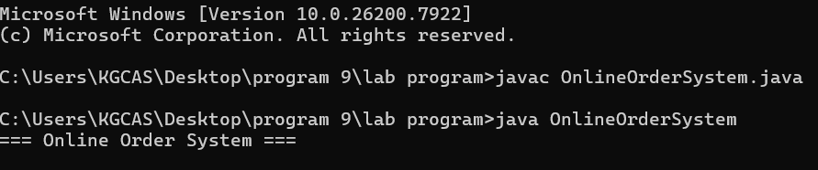

Output:
Product details
Total amount
Invoice display

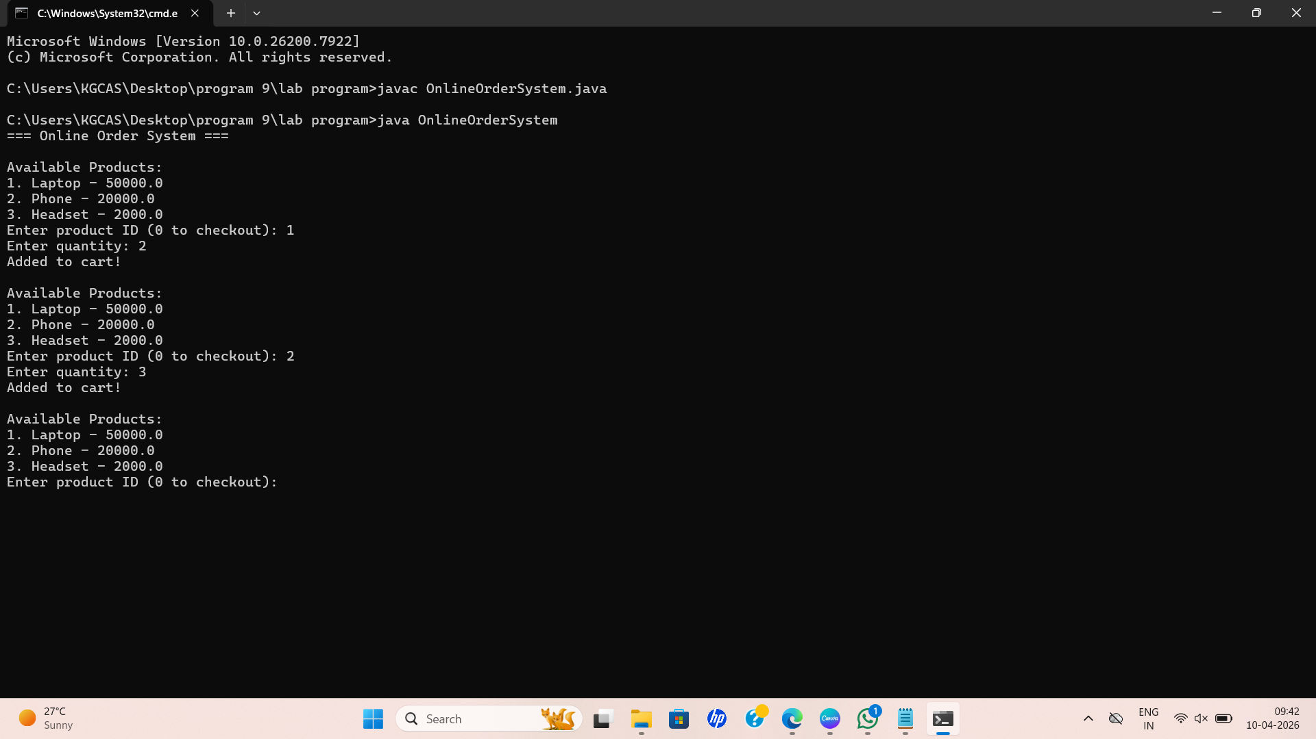

7.DISCUSSION & CONCLUSION

7.1 Discussion
The Online Order Processing and Invoice Generation System provides an efficient solution for managing business operations. It replaces manual processes with automated systems, improving accuracy and speed.
During development, several factors were considered such as usability, performance, and scalability. The system was tested under different scenarios to ensure reliability.
The results show that the system significantly reduces processing time and eliminates errors in billing. It also improves data management by storing all records in a structured database.
The system can be further enhanced by adding features such as:
- Online payment integration
- Cloud storage
- Mobile application support

7.2 Conclusion
The Online Order Processing and Invoice Generation System successfully meets its objectives. It provides a reliable and efficient solution for managing orders and generating invoices.
The system reduces manual workload, improves accuracy, and enhances customer satisfaction. It also provides better data management and reporting capabilities.
In conclusion, this system is highly beneficial for businesses looking to automate their operations and improve efficiency.

8.REFERENCES

The following resources were used during the development of this project:Books
1. Herbert Schildt, Java: The Complete Reference, McGraw-Hill Education. → Used for understanding core Java concepts like classes, objects, and method.
2. E. Balagurusamy, Programming with Java, McGraw-Hill Education. → Helped in learning basic and advanced Java programming.
3. Cay S. Horstmann, Core Java Volume I – Fundamentals, Prentice Hall. → Reference for Java syntax and program structure.
Websites
1. GeeksforGeeks https://www.geeksforgeeks.org/ → Used for coding examples and Java logic explanations.
2. W3Schools https://www.w3schools.com/java/ → Used for basic Java syntax and practice.
3. Oracle Java Documentation https://docs.oracle.com/javase/ → Official reference for Java programming

